**Island Rush V3 Technical Guide**

(User’s Manual)

This guide serves to explain how to use the game and each of its features, and doesn’t worry about explaining the ‘why’ or ‘purpose’ behind why things are the way they are, nor does it worry about correct military terminology. Instead it uses phrases like ‘air controller’ to keep things simple and quick. Please read the non-technical ‘Game Manual’ to learn military background, correct military terminology, etc... This guide is designed to be read by players, faculty, and anyone who is confused on how to play Island Rush V3.

**Users**

* **Developers** (Devs)
  + Responsible for building the game system, maintaining servers, setting up network access, fixing bugs, and other requests made by CD or Admins.
* **Course Director** (CD)
  + *Solely* responsible for creating games, setting admin passwords, and deleting games.
* **Faculty Members/Instructors** (Admins)
  + Given games to administer. They will have responsibility over resetting games, activating or deactivating games, setting team passwords, and force-logging out players still ‘logged in’ from previous gameplay. They will also monitor the games for abuse (hacking / cheating), or players who are struggling.
* **Cadets** (Players)
  + Given login credentials from admins, as well as team assignments and possibly individual commander roles. Players will play the game.

# Getting Started

The game is played via Chrome, other browsers are not officially supported and may not work. The game only allows requests from MissionNet or EDU. Admins will notify players if other networks are required. URL is typically ‘island-rush.com’ but Admins will notify if it is different. Note: Playing several games from different chrome tabs does not work and will break the game, but it is possible to play several games/logins from separate chrome profiles (such as ‘Guest’). See Appendix 1 for more info.

**Website**

Includes the homepage, troubleshooting page, credits, and Admin/CD pages. Each page has a navigation bar at the top that links to the other pages, as well as to the (work in progress) Wiki page and Report an Issue form.

**Homepage**

Left side has the player login form. Players should get their credentials from Admins and select which Controller Type(s) they wish to login as. As many groups will not always have exactly 5 members, this form is setup to allow players to login as whoever is missing and assume multiple roles. Only 1 role can be active at a time, meaning 2 players cannot both be the same type. Ideally, each player of a team of 5 will have exactly 1 distinct controller type they are assigned. The ability to switch or assign roles is up to Admins, default is to let teams decide individually who will be which controller.

Right side has the admin login form. CD will give admins their credentials.

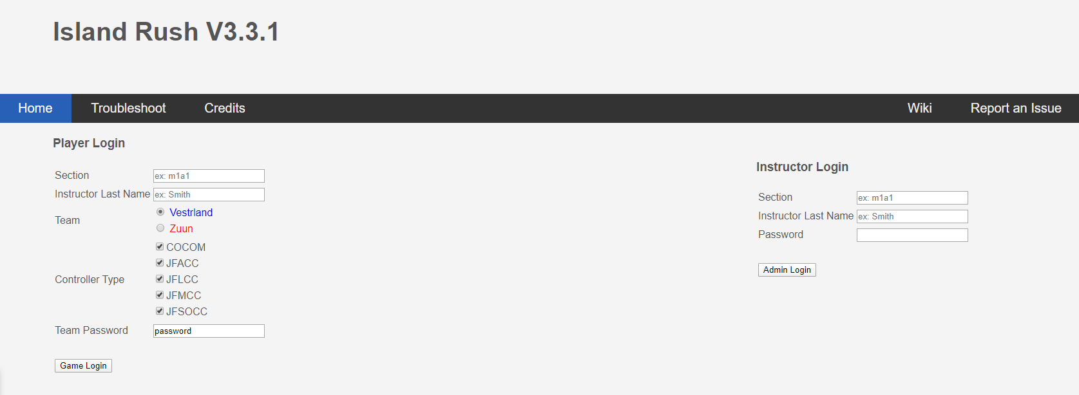

**Course Director Page**

CD page has forms to create games, view info on existing games, delete games, and reset Admin passwords.

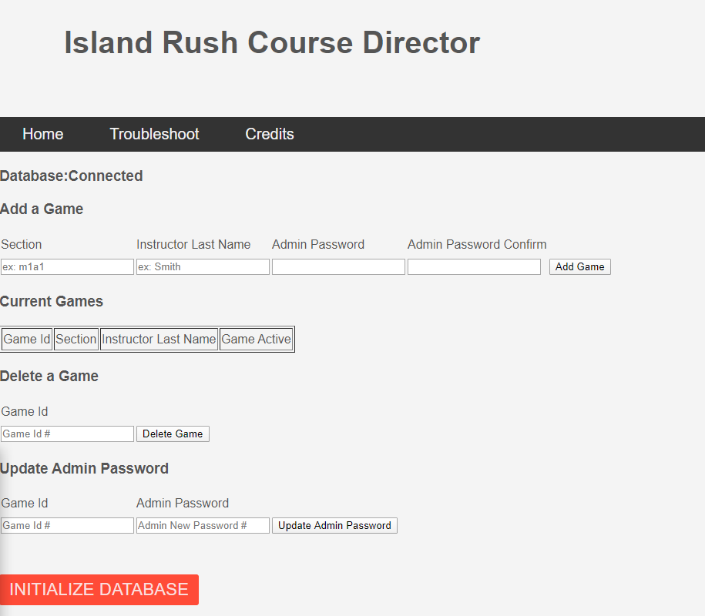

**Admin Page**

Admin page has a switch to activate and deactivate games. Deactivating a game will kick out players that are logged in, and make it impossible to log back in. This page also has a button to reset the game, putting it back into its initial state and deleting all associated game data that was generated. Additionally, there is a form to set each team’s passwords. Admins should make these passwords different. Finally, there are buttons to force individual controller types to logout, should the game not automatically log them out and they are stuck on the login screen.

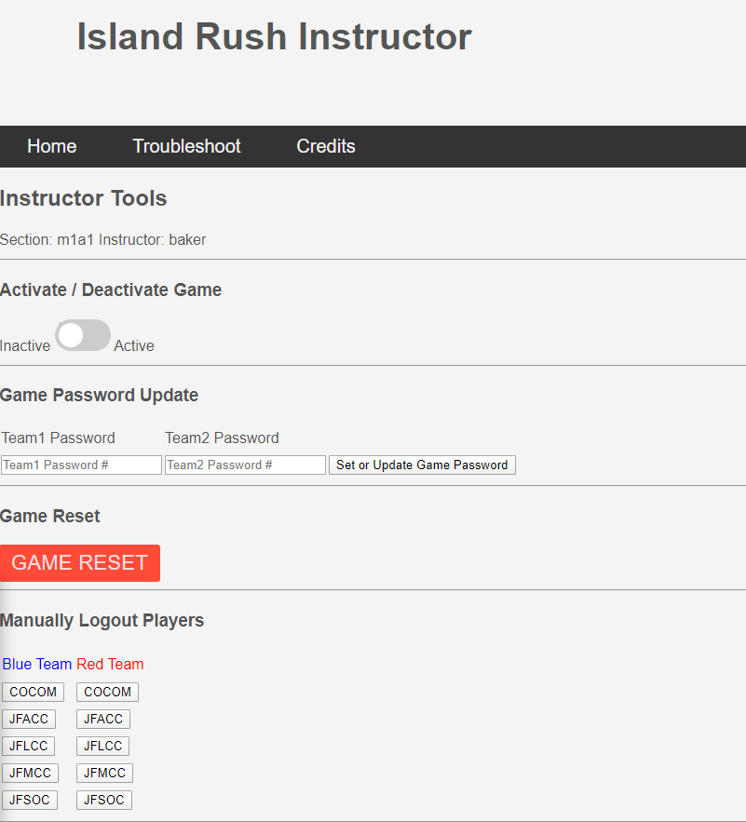

**Controller Types**

On the player login screen, there are several options for controller types. Each type has different levels of control on gameplay.

* COCOM (Main Commander / Controller)
  + Ability to change game phase. Can make purchases. Ability to use most capabilities. Makes selections for battles. Control entering / exiting containers.
* JFACC (Air Commander / Controller)
  + Make movement plans for Air pieces. Place air pieces on the board. Ability to refuel planes.
* JFLCC (Land Commander / Controller)
  + Make movement plans for Land pieces. Place land pieces on the board.
* JFMCC (Sea Commander / Controller)
  + Make movement plans for Sea pieces. Place sea pieces on the board. Ability to use Destroyer Bombardment, and use sea mines.
* JFSOCC (Special Commander / Controller)
  + Make movement plans for Special pieces. Place special pieces on the board. Use Drone Swarms, and use Land Based Sea Missiles (missiles).

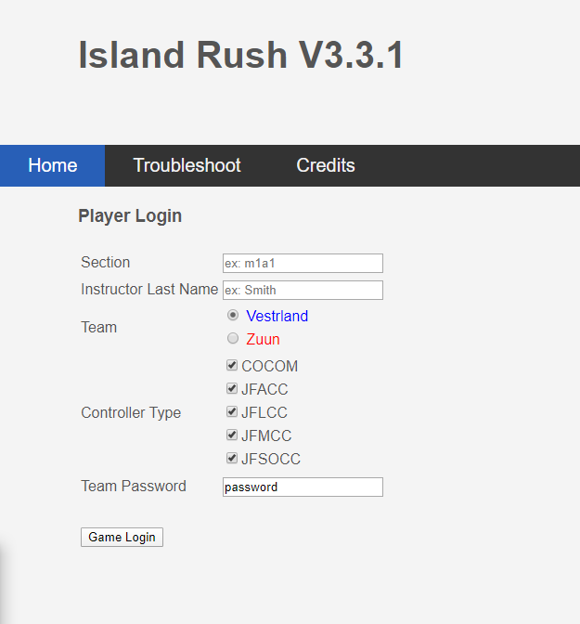

**Game Page**

Once logging into the game, you’ll see the game page. Most noticeably is the hexagon map (board). On the top left is a column of menu buttons (‘sidebar’ or ‘menu’). On the bottom row is a control bar (bottom-bar). By clicking any position on the board, a large area will appear on the bottom left to display the contents of that position (zoombox). Clicking off the board will hide the zoombox. A fresh game will also start with a News Alert in the middle, which can be minimized by clicking the button at the top left of it (popup). Other popups may appear, and should have similar minimize buttons if applicable. Many times hovering a mouse over something will reveal some information about it. Overall, if the game becomes stuck or broken, 9 times out of 10 refreshing the page will fix the issue.

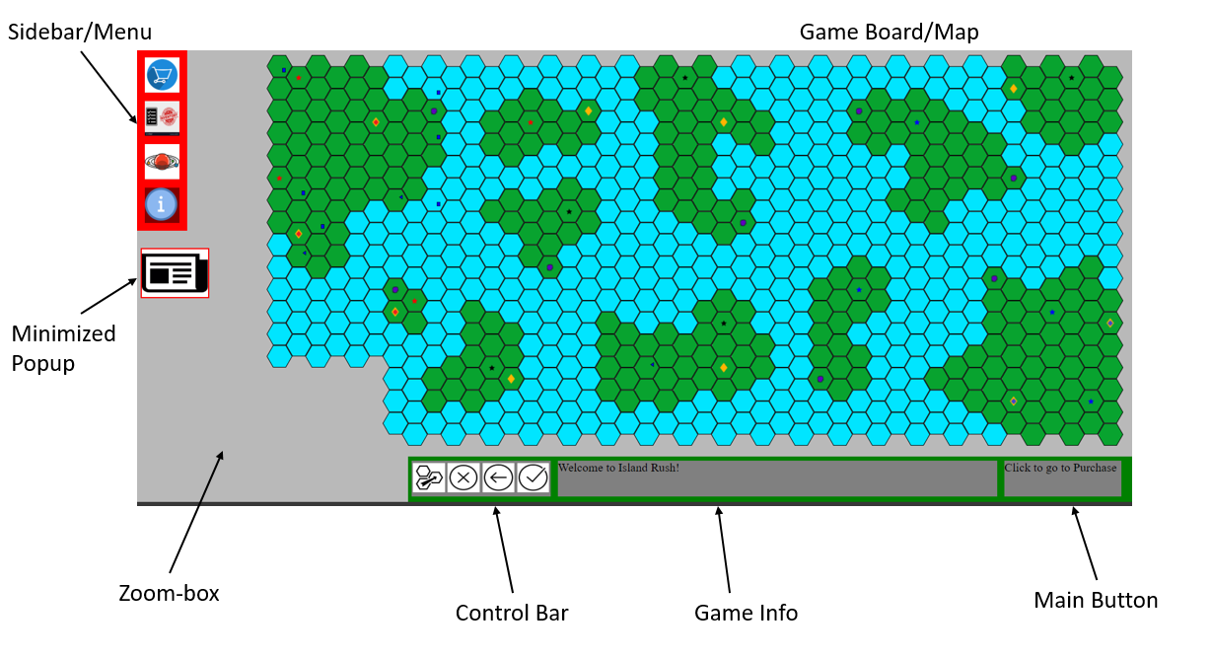

**Phases of Gameplay**

There are 4 distinct phases of gameplay that occur in a loop. One loop is called a ‘Turn’. The main controller will click the bottom right button (main button) to progress through a phase. The text on the main button and user-feedback at the bottom should assist in showing when phases change, and the game-info menu will also show the current state of gameplay.

1. Turn
   1. News Phase
      1. A News Alert will popup showing some event that may or may not affect gameplay. Currently the effects ***are not*** coded, and don’t work, so it only shows text.
   2. Purchase Phase
      1. Shop Menu should popup and allow Main Controller to purchase things.
   3. Combat Phase - 3 ‘Rounds’
      1. Round
         1. Planning ‘Slice’
            1. Individual Controllers create movement plans for their pieces.
            2. Capabilities are used here (planned or instant).
            3. Bombardment and Missile Launches are planned.
         2. Executing ‘Slice’
            1. Capabilities that were planned get executed and shown to teams.
            2. Main Controller clicks through each ‘movement’ until all movement plans by both teams are complete.
            3. Battle’s automatically occur and must be handled by each team.
            4. Air Controller can refuel pieces.
   4. Placement Phase
      1. Individual controllers can select positions on the board, then select pieces from the inventory menu to put on those positions.

**Menus**

The sidebar contains 4 buttons to 4 different menus. Clicking these buttons will select and deselect the menu popups. Clicking the button again, or outside the board will also deselect the popups. These are the 4 menus, indicated in the order of their buttons (from top to bottom)

1. Shop Menu 
   1. Displays pieces and capabilities to purchase, shows points in top left.
   2. Click to place an item into the cart, click the item in the cart to refund it.
   3. Click Confirm Purchase at the bottom to put cart pieces in Inv (can’t undo)
2. Inventory (Inv) Menu 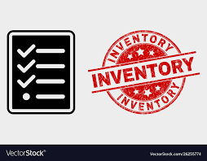
   1. Displays pieces and capabilities currently owned by the team.
   2. During planning, click capabilities to use.
   3. During placement, click a position and then the Inv piece to place it on the board.
3. Space/Capabilities Menu 
   1. Currently work in progress.
   2. Shows active anti-sat missiles, and if cyber defense is active for your team.
4. Game Info Menu 
   1. Shows the current state of gameplay.
   2. Shows information about who is logged in.

**Planning**

When the combat phase begins, players must make individual plans for the pieces they control. These plans consist of a series of ‘steps’ or ‘movements’ for the piece to make. Pieces move 1 position at a time. Planning will be restricted on a piece’s allowed moves and allowed terrain. Fuel does not restrict planning, as players are expected to account for mid-plan refueling.

Planning is controlled with the buttons on the left side of the bottom-bar.

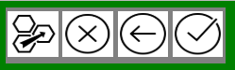

To start a ‘plan’, first select a piece. Next, click the far left planning button to enter the planning mode. The screen should show a yellow background. You can click the X button to cancel at any time. Next, start clicking a ‘path’ of positions for the piece to take. If you run out of allowed moves, or make a wrong selection, the user-feedback will indicate what went wrong. Clicking the left arrow button will ‘undo’ the last position selected on the path. When the plan is complete, select the check-mark button to submit and save it. Now select the piece again, it’s confirmed plan will be highlighted if you wish to review it. You can select the X button to delete it, or start a fresh one.

The main commander may also now select capabilities to use from the inventory. Some capabilities, like remote sensing, work instantly. Others are ‘planned’ and will be executed on the transition into the ‘execute’ slice. Destroyer bombardments and Missile attacks are considered ‘capabilities’ to be planned, but require the individual pieces on the board to use. These actions are set during this phase (see individual piece info for more details on how to use them).

Finally, pieces entering and exiting ‘containers’ shall occur during this slice.

**Executing**

Once planning is done by both teams, the game transitions from the planning slice into the executing slice. Upon this transition, any capabilities that were planned will go into effect. These may appear on the board visually, or with user-feedback. After this transition, the movements are ready to be ‘stepped’ through. The main commander will click the main button to ‘step’ through their plans. Once each team’s commander clicks to step, the pieces will move 1 position according to their plans. If friendly and enemy pieces end up in the same position, or cross positions, a battle will automatically occur and need to be handled by each team. If no plans are made, the ‘step’ will immediately transition to the start of the next round (or phase if its the last round). If one team runs out of ‘steps’ for their pieces, they will wait while the other team continues to ‘step’. If battles or other events occur, the waiting team may need to click to step again to indicate they are ready to move on. Another thing to note is that SAMs will automatically attempt to kill visible enemy air pieces within a certain range. Each SAM fires once per ‘step’. See Appendix for more values.

**Visibility**

As pieces move around the board, they reveal enemy pieces. A visibility matrix determines which pieces see what other pieces and at what ranges. (See appendix). Remote sensing can also uncover things. Visibilities are also updated on certain events, such as battles.

**Containers**

‘Containers’ are pieces that can hold other pieces inside of them. Pieces that enter containers will be refueled. A piece’s contents can be viewed at any time, but entering and exiting can only occur during the planning slice. Here is a list of container pieces and the sub-pieces they can hold.

* Transport 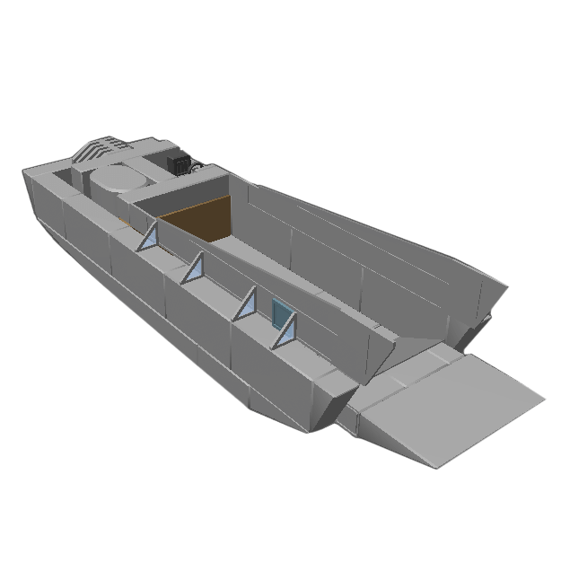
  + max of 3 infantry, or 2 infantry and 1 vehicle unit (tank, convoy, artillery, SAM, or helicopter)
* C-130 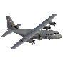
  + 1 SOF team
* Aircraft Carrier 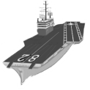
  + 3 fighters, or 2 fighters and 1 C130, or 1 fighter and 2 C130s, but never 3 C130s, 2 Helicopter at any given time
* Air Transport 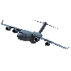
  + 1 marine infantry OR 1 army infantry

To put a piece inside a container, or to move it out, first open the container popup. Do this by double-clicking the container piece (in the zoombox). Once the popup is open, it should show outer and inner pieces. Click on a piece to transfer it inside or outside the container. The owner of the piece being moved is in charge of controlling this process, and must coordinate with the owner of the container piece.

Transports will show outer pieces from adjacent land positions, as they can only accept pieces from a land position 1 hex away. When clicking to remove a land piece from a transport, the popup will close momentarily and allow you to click which position you wish to put it on. This is because a transport may be next to more than 1 land position. Other containers only work within the same position.

There are other constraints on when to use containers. Air Transports may not ‘airdrop’, and should only transfer pieces when over a friendly airfield. C130s may airdrop SOF teams anywhere, but like Air Transports may only ‘load up’ on controlled airfields.

**Battles**

Note: Eventually will show ‘need to roll’ values while targeting.

Battles occur automatically and may appear after a ‘step’ occurs during execution. Currently, battles happen when any 2 opposing pieces meet in the same position, or cross into each other’s previous positions. Battles must be handled one by one. The board will highlight in red which position(s) the battle is taking place in. The battle will likely start as ‘minimized’, similar to how other popups are minimized. Click the minimize button on the left side of the board when it appears, to have the battle popup appear.

The battle popup shows friendly pieces on the left, and enemy pieces on the right. Each row shows pieces with a numbered index, to differ multiple pieces of the same type (To help keep track of which pieces are targeted). To target a piece, first select a friendly piece on the left by clicking it. It should highlight the piece as ‘selected’. Next, click an enemy piece on the right side to target. Once it is targeted, it should appear on the left side next to the piece you were using. Each piece has an attack value against every other piece, please see the Appendix for an Attack Matrix. Each attack value is the dice-roll needed to kill its target. Once all target selections are made, the main commander can click the button at the bottom of the popup to confirm all selections. Once both teams have confirmed their selections, the server will calculate all dice rolls and show the results to each team. Piece ‘blocks’ (the rows) will visually indicate if they ‘won’ their roll against their target. The enemy targets will also be shown, as well as which enemy pieces ‘won’. Once done analyzing the results, the players can click the ‘return to battle’ button at the bottom. Killed pieces are automatically removed from both sides.

If there are no more selections possible (no more pieces left for 1 or both teams), or both teams don’t want to battle anymore, clicking the ‘confirm selections’ button with 0 selections will indicate to the server to end the battle. This will close the popup and continue the rest of the execution step. If multiple battles occurred, another battle may appear immediately after the last one has finished. All battles/events must be handled before the next ‘step’ can occur.

**Refueling**

Note: Not yet coded. (may not work exactly as indicated)

Refueling can be conducted during any ‘step’. Double click a Tanker piece 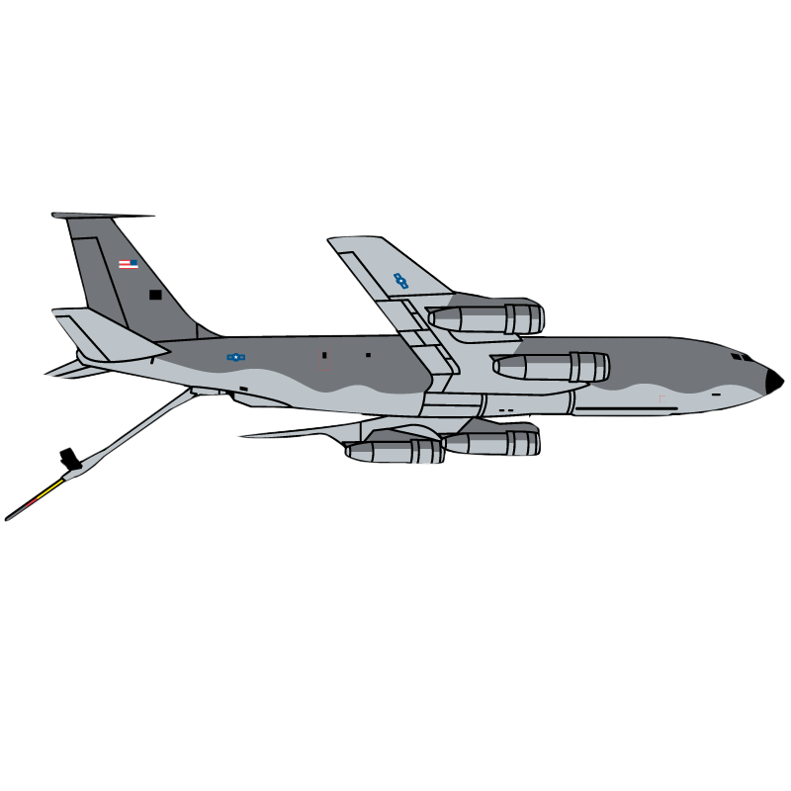 to open the Refuel Popup. This popup will show tankers on the right and pieces to refuel on the left. Click the pieces on the left you wish to refuel. Click the bottom confirm button to save the transfer, and close the popup. Pieces that are refueled can only be ‘filled’ to the max, there is no in-between or splitting.

Helicopters are constantly refueled while they are over land positions, and will decrease fuel over the sea positions. Pieces that do not have any plans will lose 1 fuel for ‘loitering’ per round of combat. Pieces that do have plans, will lose 1 fuel for every ‘step’ that they take. Planes over controlled airfields will be automatically refueled. The same is true for planes that land on carriers. Another note is that planes will lose another fuel for entering and participating in battles.

**Flags**

**  **

Flags appear as colored stars on the map. Owning a flag means owning the entire island. Points are given to each team every turn based on which islands they own. Hover the mouse over each flag to get more info about them. To capture a flag, your team must be the only team with ground pieces in the position. There are 2 flags on each team’s main island. Both of the flags must be captured to own the island and get the points for it. Each team starts the game with several islands already owned. This is a list of pieces that can capture flags: Army, Artillery, Tank, Marine, Convoy, SAM, SOF.

**Airfields**

** **



  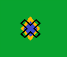

Airfields appear as colored diamonds on the map. Planes must be placed on owned airfields to start. Owning an airfield means letting planes land on it and get refueled, as well as letting troops enter plane containers. When planes are over an airfield, hover the mouse of the piece in the zoombox and you should see a ‘Landed’ text along with the other info. SOF teams entering an unguarded enemy airfield will destroy planes. Capturing an airfield is similar to capturing a flag. This is a list of pieces that can capture airfields: Army, Marine, SOF.

**Missile Silos**



Missile Silos appear as purple splotches on the map. Missiles must be placed on missile silo positions, and must also be on completely owned islands. There must not be any enemies in the position as well. SOF teams, moving onto the silo position, will destroy enemy missiles if they are unguarded.

**Combat Boost**

Note: Not yet coded

Certain piece combinations during battle will boost the attack of those pieces by 1 value, meaning whatever random dice is rolled gets +1. If the combination is detected, it should be visually indicated in the battle popup. These are the combinations:

* Armored Brigade Combat Team (Armored BCT): Two infantry units, one tank battalion, one convoy, one artillery battery.
* Marine Expeditionary Unit (MEU): Three marine infantry units, one helicopter squadron, one artillery battery.
* Carrier Strike Group (CSG): One Aircraft Carrier, One fighter squadron, two destroyers, one submarine

**Placements**

Pieces are placed onto the board from the inventory during the place phase. To place a piece, first click the position you which to place it in. Next, select the Inv menu and then click the piece(s) you wish to put onto the position. The pieces should transfer from the inventory to the zoombox. Currently there is no ‘undo’ button, so be careful about placements. Placements must conform to rules of terrain, as well as planes being placed on airfields. Pieces are only placed on the main starting islands. The exceptions to this rule are Radars and Missiles. Missiles are placed in silos, while Radars are placed on any controlled island in a position with friendly ground units.

**Pieces**

Most piece information, such as cost, movements, fuel, can be found by hovering the mouse over the piece from within the shop menu. Hovering the mouse over a piece in the zoombox will show how many moves/fuel are left for that particular piece. Most pieces don’t have specific capabilities, but rather are specialized at certain visibilities, attacks, or defenses. Certain pieces, however, do have certain abilities.

Destroyers have the ability to conduct a bombardment against an enemy piece on a land position nearby. This ability can be used once per combat round, and is setup during the planning phase. Double click the destroyer to start using the ability, then click the position, then the piece you want to attack. After the bombardment is confirmed, hovering the mouse over both the destroyer and targeted piece should show additional information.

Missiles (LBSMs) have the ability to target nearby enemy sea pieces. This ability, like bombardment, is used during the planning phase but it can only be used once. Closer targets have a higher chance of getting hit. Just like bombardment, the selection to target pieces with a missile attack is the same.

**Capabilities**

Capabilities are (mostly) used by the main commander to effect gameplay. Each capability is unique, but many are setup in similar ways. To start using any capability, you must be in the planning slice. Note that capability can be used at any planning slice, not just the first one. This means that capabilities that last for x rounds may carry over into the next turn. Most capabilities are ‘planned’ and won’t start until the transition into the executing slice. Capabilities that take immediate effect will be indicated. Here is the list of capabilities.

Click a capability in the inventory to start setting it up.

* ATC Scramble 
  + Click any airfield on the board. After confirming, that airfield will become ‘scrambled’ and not allow landing or refueling for 3 rounds.
* Cyber Dominance 
  + Once clicked and confirmed, the enemy will be prevented from using offensive cyber effects. (ATC Scramble, Missile Launch Disrupt, Comm Interrupt). If the enemy chooses to use those offensive cyber effects after this has activated, those effects become wasted.
* Cyber Dominance Check 
  + Once clicked and confirmed, the user-feedback will indicate if the other team currently has cyber dominance activated. This occurs immediately.
* Missile Launch Disruption 
  + Click any missile silo and it will prevent missile (LBSM) attacks (launching against sea units) for 3 rounds.
* Communications Interruption 
  + Click a position on the board, an area will highlight. After confirming the area, enemy pieces within the area will be ‘stuck’ and lose their plans. This lasts for 3 rounds.
* Remote Sensing 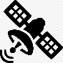
  + Click a position on the board, an area will highlight. After confirming the area, enemy pieces will be revealed in that area immediately. It will not show submarines, SOF teams, or stealth planes. This lasts for 9 rounds or until shot down by anti-sat missile capability (which may also be immediately).
* Rods From God 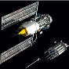
  + Click a position on the board to hit. After confirming, the position will be ‘hit’ and all pieces will be deleted.
* Anti-Satellite Missiles 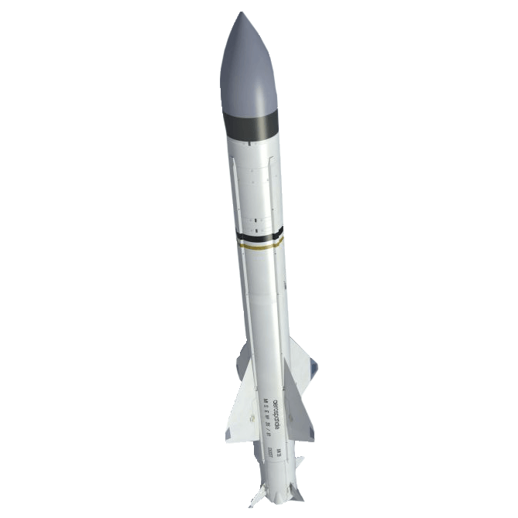
  + Once confirmed, they will sit in the space menu as ‘activated’. These last for 6 rounds or until there is a remote sensing satellite to takeout (which may be immediately).
* Golden Eye 
  + Click a position, an area will highlight. After confirming the area, all Air units will be destroyed and ground units will be ‘stuck’ for 12 rounds.
* Nuclear Strike 
  + Click a position, an area will highlight. After confirming the area, all positions in that area will be deleted and the positions will be marked as ‘nuked’. 
  + Pieces will no longer be able to survive within them. This effect lasts forever. There are restrictions on using this too close to the main islands.
* Humanitarian
  + TODO: not yet coded (relies on News Alerts being coded (they are not))
  + If implemented, will likely appear with news alerts as an option to ‘invest’ points to get back more later.
* Biological Weapons 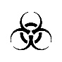
  + Click a position. After confirming that position, the position will be marked as ‘bio-hazard’ for 9 rounds. All ground pieces in the position, or that enter, will be killed.
* Sea Mines 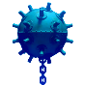
  + Used by Sea Commander
  + Click a friendly transport piece to deploy it from. Once confirmed, it will be shown in the zoombox of that position. Because it can kill any entering piece, it may appear as an enemy on the board. Any sea pieces that enter will get destroyed and the mine will get used up (choose 1 randomly if multiple enter).
* Drone Swarms 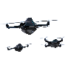
  + Used by the Special Commander
  + Click a friendly C130 to deploy it from. Once confirmed, it will be shown in the zoombox of that position. Similar to sea mines, it may appear as an enemy since it can kill any entering piece. Any air pieces that enter will get destroyed and the swarm will get used up (choose 1 randomly if multiple enter). This lasts for 9 rounds.
* Insurgency 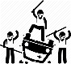
  + Click a position. Once confirmed, all enemy pieces in that position have a ⅓ chance of getting deleted.
* Raise Morale 
  + A popup will appear showing the 4 types of pieces (air, land, sea, special). Select one to give their pieces +1 moves for the next 3 rounds. This can only be used once per type, meaning all 4 can be boosted but one can’t be boosted several times. Fuel restrictions will still apply.

**Victory**

A team wins when they capture both flags on the other team’s main island. *This may or may not be visually indicated yet, just know that it’s the overall objective.*

**Appendix**

1. Playing multiple games / logins at the same time, use separate chrome profiles for each login.
   1. <https://www.pcworld.com/article/2089364/how-to-create-and-manage-multiple-user-profiles-in-chrome.html>
2. Attack Matrix

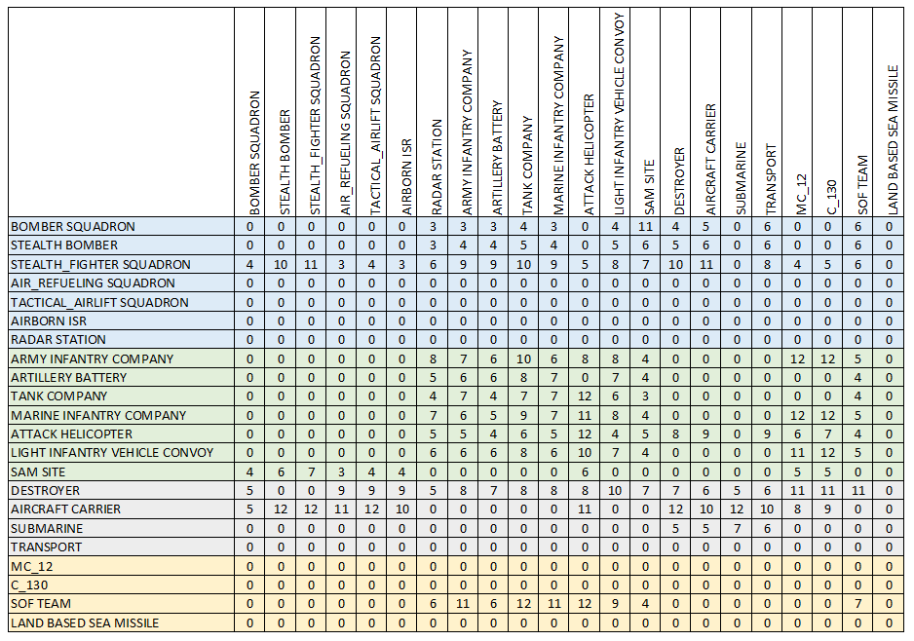

1. Visibility Matrix

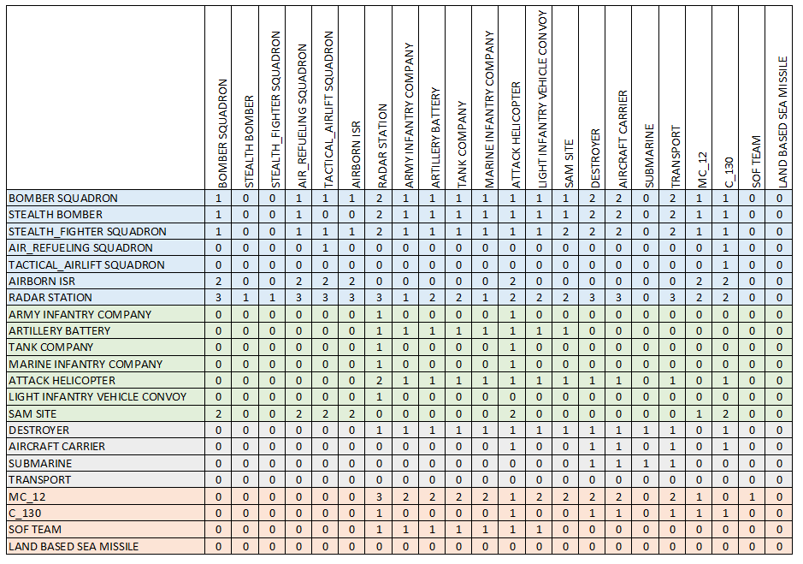

1. Moves-Fuel-Cost Matrix

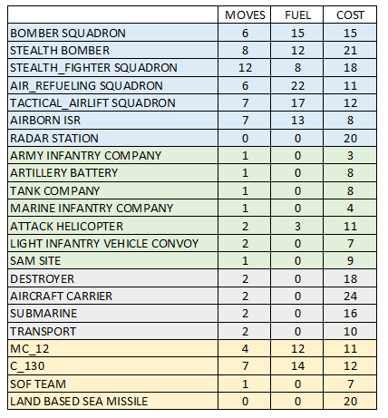

1. Other Constants
   1. TODO: Link to file with other constants
   2. Ranges / percent chance hits (bombardment, missile, sam)
   3. Things like what pieces are ‘ground defenders’ for flags?
   4. Lots of weird values and things that we should show

**Note from Developers**

“This game has a lot going on, different pieces doing different things, lots of capabilities, and tons of unique game rules and ‘game-isms’ to put in. With any complex system, there are always bugs and defects. With this system in particular, we try our best to make the game work according to the rules listed above, but we are sure to miss a few things. PLEASE be on the lookout for anything that might not fit within the rules listed. This is so we can figure out who messed up the code, and punish them by taking away their keyboard (Also we’ll fix the bug).“

V/R

Spencer Adolph

Lead Developer